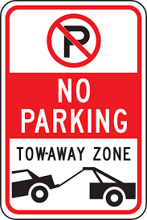**NO PARKING VIOLATION**

3035,Delhi,India| 222 555 7777

Fax:123-123-123456

**PAYMENT RECEIPT**

Date:Sun Jan 21 2024 17:50:46 GMT+0530 (India Standard Time)

Receipt No.:

**BILLED TO**

Client Name: Om Ashokbhai Oslaniya

Address: surat  
 Phone:

Memo Date: Thu Jan 18 2024 17:24:27 GMT+0530 (India Standard Time)

|  |  |  |
| --- | --- | --- |
|  |  | **Amount** |
| **Parking Violation** |  | **470.77 Rs.** |
|  |  |  |
| **Subtotal 470.77 Rs.** | | |
| Gov Tax (7%) |  | 29.23 Rs. |
| **Total Amount** |  | **500.00 Rs.** |

**PAYMENT DETAILS**

**Payment Date :**  {paydate}

**Payment Method:**  Online

**Amount Paid :** 500.00 Rs.

Transaction No : 190840.